- Open Excel (Start, All programs, Microsoft Office and Microsoft Excel)
- Save this as Student in your ICT folder
Enter data
- Type your first name and last name in cell A1 and press enter
- Click in B1 and type your postcode, press enter
- Move to cell A5 and type Students, press enter
- Enter text as shown below
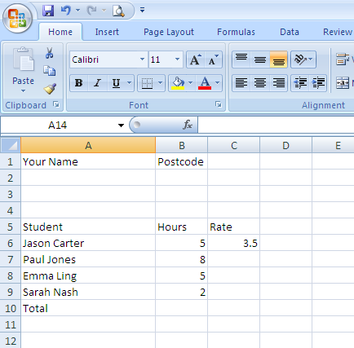

- Widen Column – point mouse arrow over the join between column heading A and B. It should turn into a four-sided arrow. Double click the mouse and it will do it for you.

- Save your work

- Click on B6 and, holding your left mouse button down, highlight to B10
  - Right click the mouse
  - click format cells
  - Numbers tab
  - Click on number from the list
  - select 0 decimal places
  - ok

- Click on C6 and, holding your left mouse button down, highlight to C10
  - Right click the mouse
  - click format cells
  - Number tab
  - Click on Currency in list
  - Ok

- Text formatting
  - Click in A5 and drag to C5 to highlight these
  - Click Bold on the toolbar

- Centre headings
  - Click in A5 and drag to highlight to C5
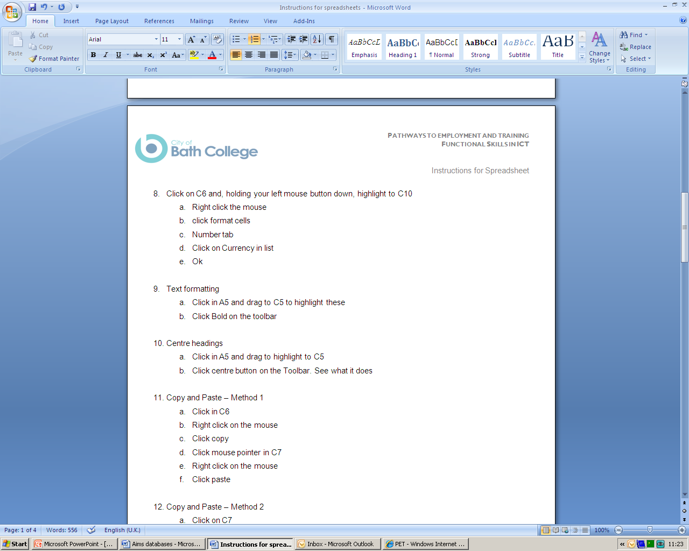
  - Click centre button on the Toolbar. See what it does

- Copy and Paste – Method 1
  - Click in C6
  - Right click on the mouse
  - Click copy
  - Click mouse pointer in C7
  - Right click on the mouse
  - Click paste

- Copy and Paste – Method 2
  - Click on C7
  - Point the mouse over bottom right hand corner of the cell, a thick cross will appear
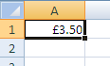
  - Click the left mouse button and drag down to C9, the number in C7 will be copied in each cell

- Your spreadsheet should look like this
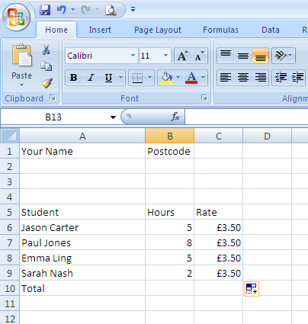

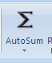
- Using AutoSum to insert a formula
  - Click in B10
  - Click on Formulas on the toolbar then click then click enter
  - Repeat this in cell C10, you should see £14.00

- Change contents of a cell
  - Make the following changes
    - Change Jason’s hours to 7
    - Change Pauls to 10
    - Emma’s to 7
    - Sarah’s to 4

- Copy a number to selected cells
  - Click in C6 type 4 and press enter
  - Click in C6 again, point mouse over the bottom right hand corner, a thick cross will appear
  - Click and hold down and drag to C9

- Insert a row
  - Click in A8
  - Right click
  - Select insert
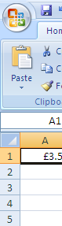
  - Select insert a row, click ok
  - Enter David King 9 4.00
  - Click Save

- Delete a row
  - Click on Row heading 2 so that the whole row is highlighted
  - Right click the mouse
  - Click delete

- Insert header and footer
  - Select insert on the toolbar
  - Click on header and footer
  - Click on the left of the header and insert your name
  - Click in the middle and click on the current date
  - Click in the right side of the header and click file name

- Insert Gridlines and row and column headings
  - Click on page layout on the toolbar
  - Select both view and print in the gridlines and headings
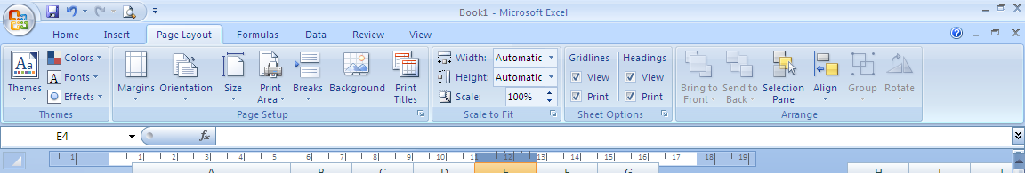
  - Save your work

  - Print your work

